**Exercise 7: Packages**

**Scenario 1: Group all customer-related procedures and functions into a package.**

**Question: Create a package CustomerManagement with procedures for adding a new customer, updating customer details, and a function to get customer balance.**

Package Creation

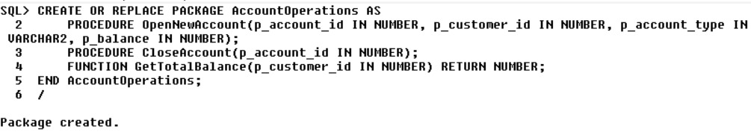

Package body creation

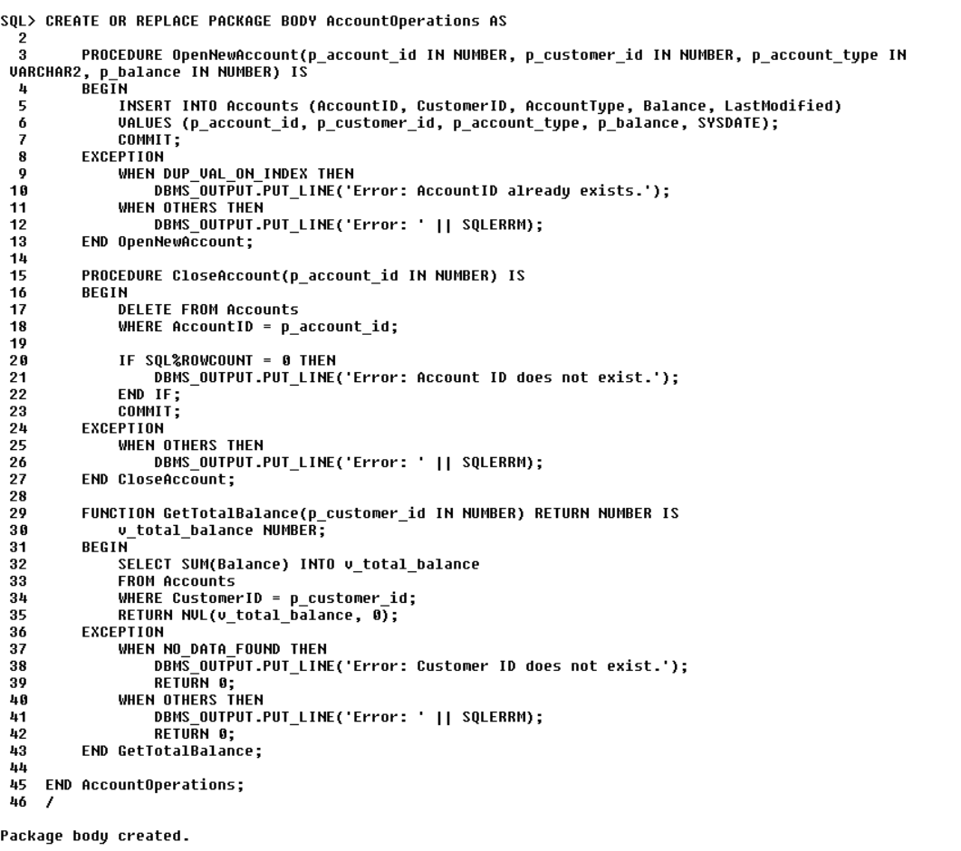

Adding Customer Details   
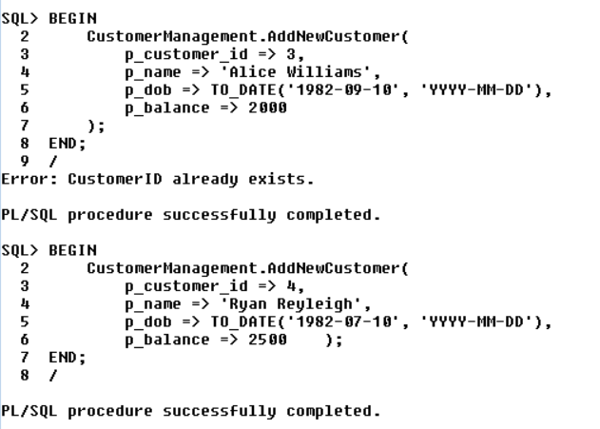

Update Customer Details  
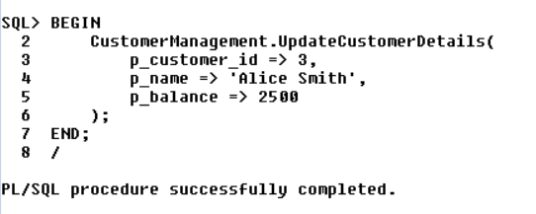

Check Balance of the customer  
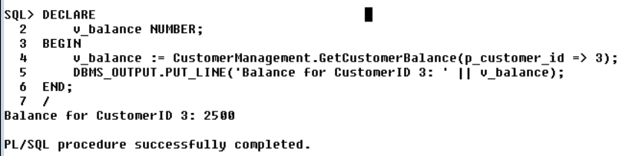

**Scenario 2: Create a package to manage employee data.**

**Question: Write a package EmployeeManagement with procedures to hire new employees, update employee details, and a function to calculate annual salary.**

Package creation

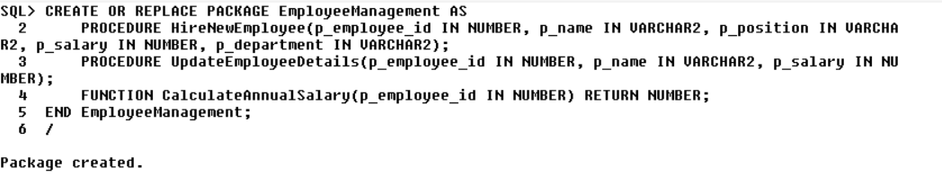

Package Body Creation

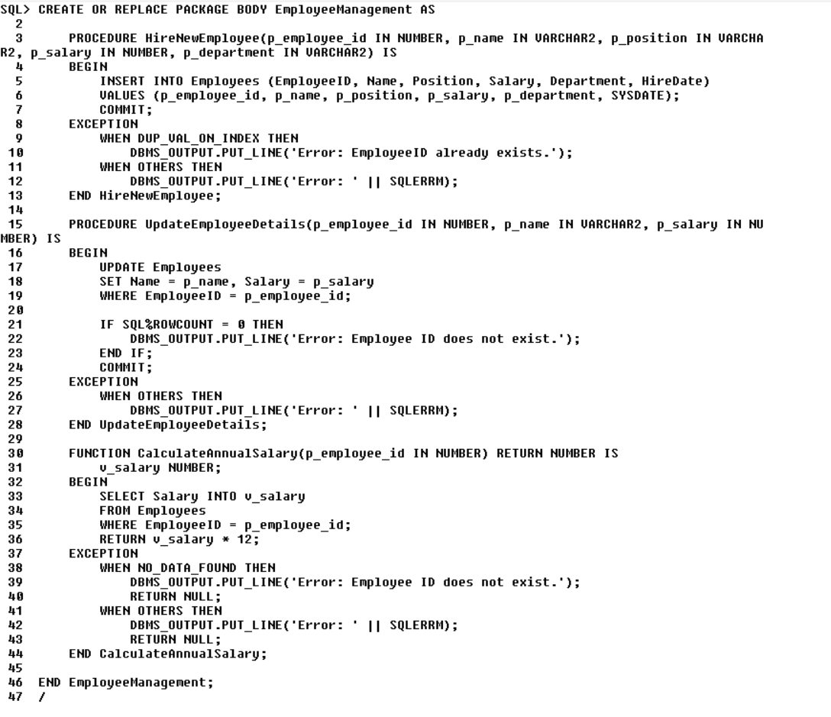



Hiring New Employee

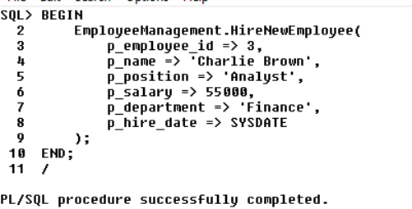

Updating Employee Details

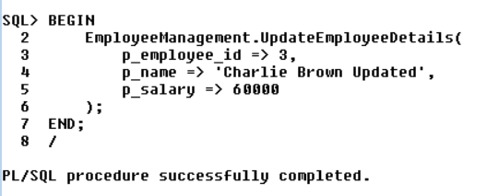

Calculating Annual Salary  
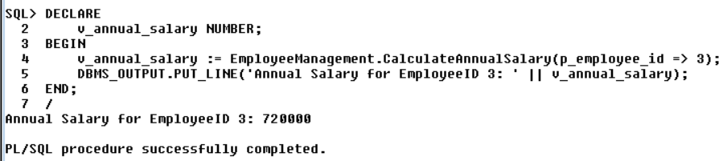

**Scenario 3: Group all account-related operations into a package.**

**Question: Create a package AccountOperations with procedures for opening a new account, closing an account, and a function to get the total balance of a customer across all accounts.**

Package Creation

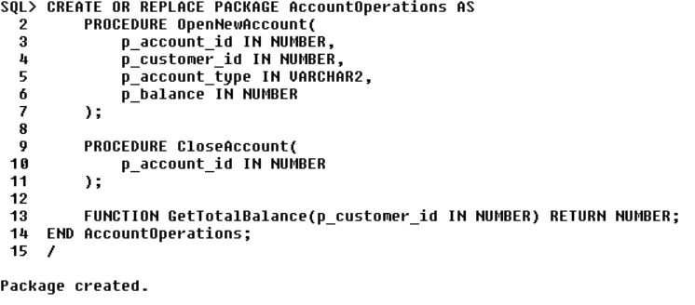

Package Body Creation

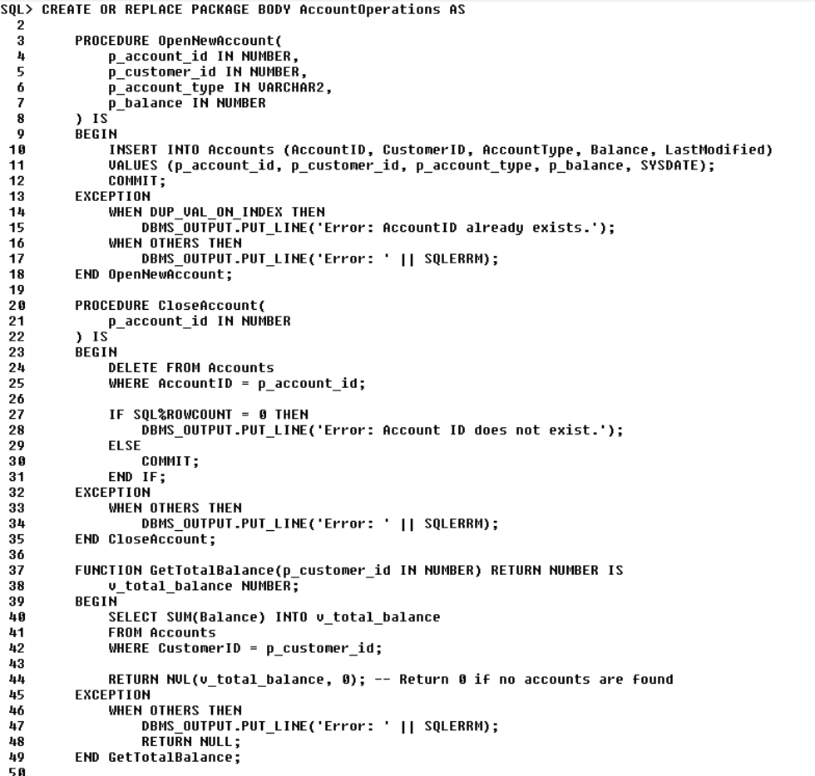

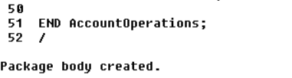

Account Creation   
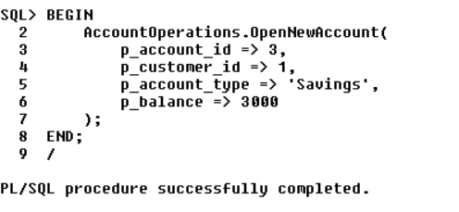

Account Closing  
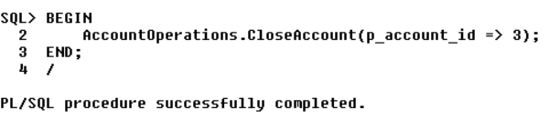  
  
Get Total Balance

